Sri Lanka Institute of Information

Technology

**Database Management Systems**

**for**

**Securit**

**y**

**-**

**IE2024**

Lab Submission 0

4

**IT22151056**

**De Silva K.R.K.D**

**Activity 01**

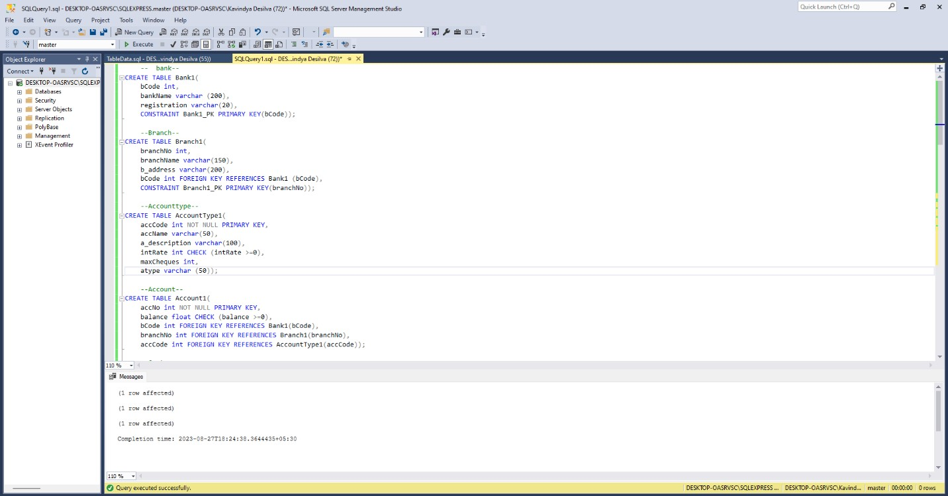

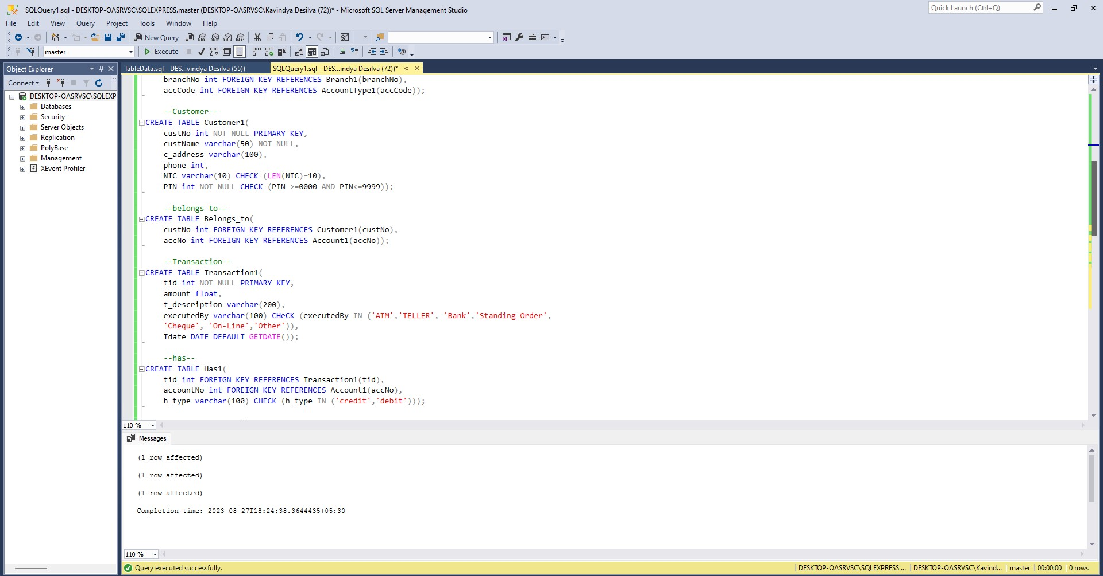

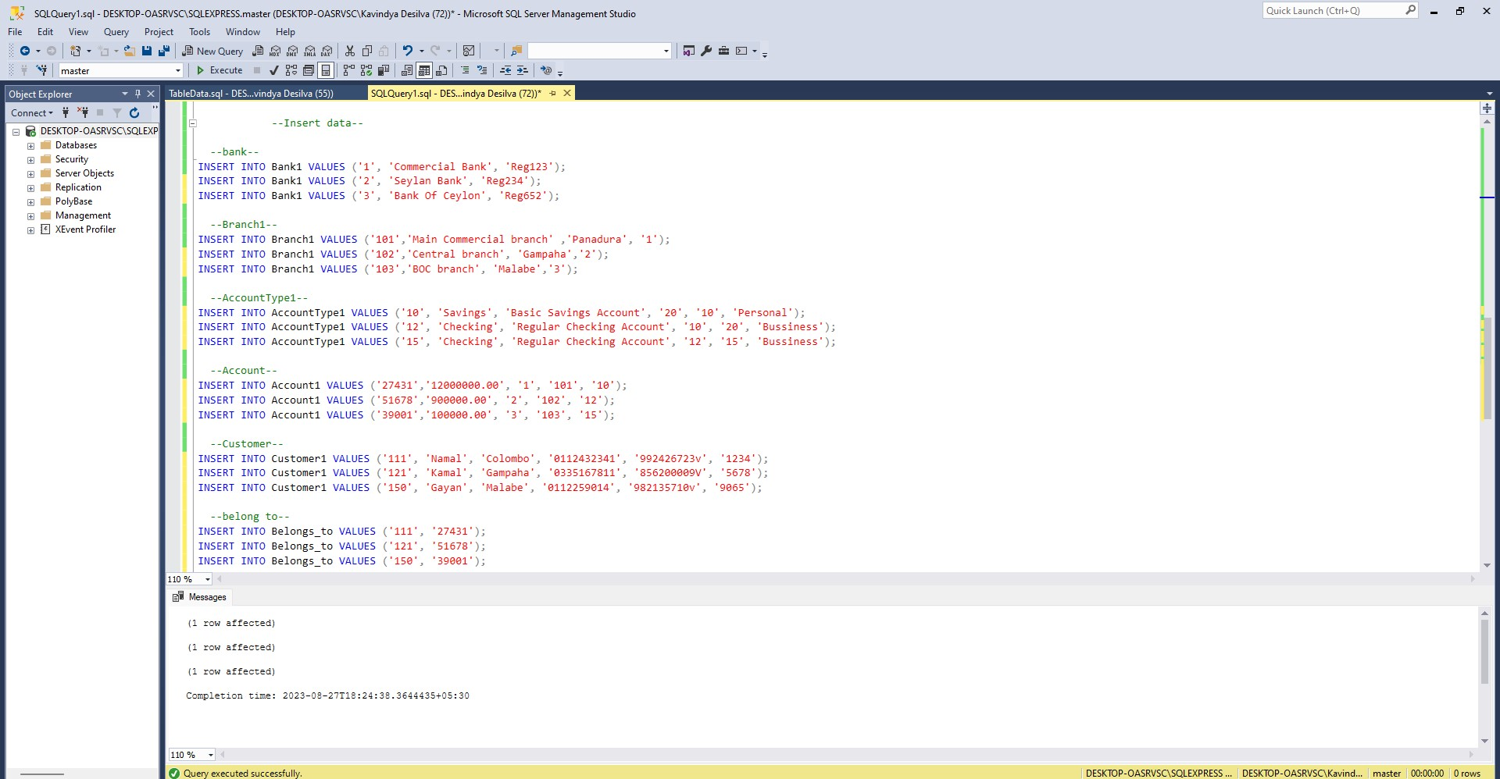

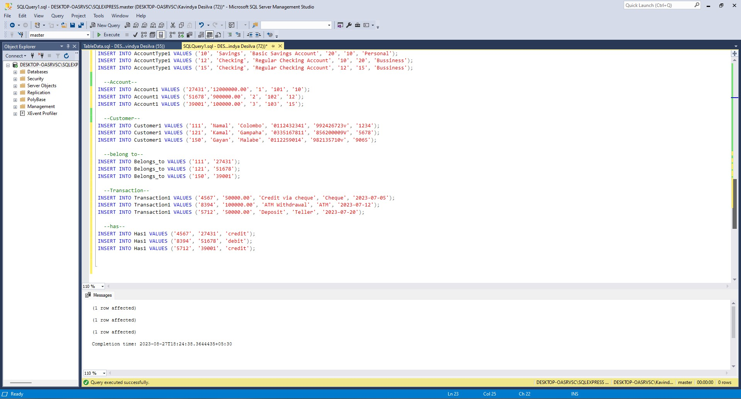

**Activity 02**

--01--

SELECT accNo FROM Account1

WHERE balance > 1000000;

--02--

SELECT Sum(T.amount)

From Transaction1 T,Has1 H

WHERE T.tid = H.tid AND H.accountNo = '51678' AND T.executedBy = 'Cheque';

--03--

SELECT A.accNo, A.balance FROM Account1 A

jOIN Branch1 B ON A.bCode = B.bCode AND A.branchNo= B.branchNo

JOIN Bank1 BK ON B.bCode = BK.bCode

WHERE B.branchName='Panadura' AND BK.bCode ='1';

--04--

SELECT A.accNo, A.balance, ACT.accName

FROM Account1 A

JOIN Customer1 C ON A.accNo =C.custNo

JOIN Bank1 B ON A.bCode = B.bCode

JOIN AccountType1 ACT ON A.accCode = ACT.accCode

WHERE C.NIC = '856200009V' AND B.bankName = 'Sampath Bank';

--05--

SELECT SUM(A.balance)

FROM Account1 A

JOIN Bank1 B ON A.bCode = B.bCode

JOIN Branch1 BR ON A.branchNo = BR.branchNo

WHERE B.bankName = 'Seylan Bank' AND BR.b_address LIKE '%Gampaha';

--06--

SELECT SUM(T.amount)

FROM Transaction1 T

JOIN Has1 H ON T.tid = H.tid

JOIN Account1 A ON H.accountNo = A.accNo

JOIN Branch1 B ON A.bCode = B.bCode AND A.branchNo = B.branchNo

JOIN Bank1 BK ON B.bCode = BK.bCode

WHERE BK.bankName = 'Commercial Bank'

AND T.executedBy = 'ATM'

AND T.Tdate BETWEEN '2021-07-01' AND '2021-07-10';

--07--

SELECT C.custName

FROM Customer1 C

JOIN Belongs_to BT ON C.custNo = BT.custNo

JOIN Account1 A ON BT.accNo = A.accNo

JOIN Bank1 BK ON A.bCode = BK.bCode

GROUP BY C.custName

HAVING SUM(A.balance) > 10000000.00;

--08--

SELECT DISTINCT H.accountNo

FROM Transaction1 T

JOIN Has1 H ON T.tid = H.tid

JOIN Account1 A ON H.accountNo = A.accNo

WHERE T.executedBy = 'ATM'

AND T.Tdate BETWEEN '2021-07-01' AND '2021-07-31'

AND T.amount > 100000.00;

--09--

SELECT DISTINCT C.custName

FROM Customer1 C

JOIN Belongs_to BT ON C.custNo = BT.custNo

JOIN Account1 A ON BT.accNo = A.accNo

JOIN Branch1 B ON A.bCode = B.bCode AND A.branchNo = B.branchNo

JOIN Bank1 BK ON B.bCode = BK.bCode

JOIN AccountType1 AT ON A.accCode = AT.accCode

WHERE BK.bankName = 'Bank of Ceylon'

AND AT.accName = 'Current'

AND NOT EXISTS (

SELECT 1

FROM Account1 SA

JOIN AccountType1 SAT ON SA.accCode = SAT.accCode

WHERE SAT.accName = 'Savings' AND SA.accNo = A.accNo

);

--10--

SELECT DISTINCT A.accNo

FROM Account1 A

JOIN AccountType1 AT ON A.accCode = AT.accCode

WHERE AT.accName = 'Savings'

AND NOT EXISTS (

SELECT 1

FROM Transaction1 T

JOIN Has1 H ON T.tid = H.tid

WHERE T.Tdate BETWEEN '2021-07-01' AND '2021-12-31'

AND H.accountNo = A.accNo

);